2D Physical World Report

Description of practical design device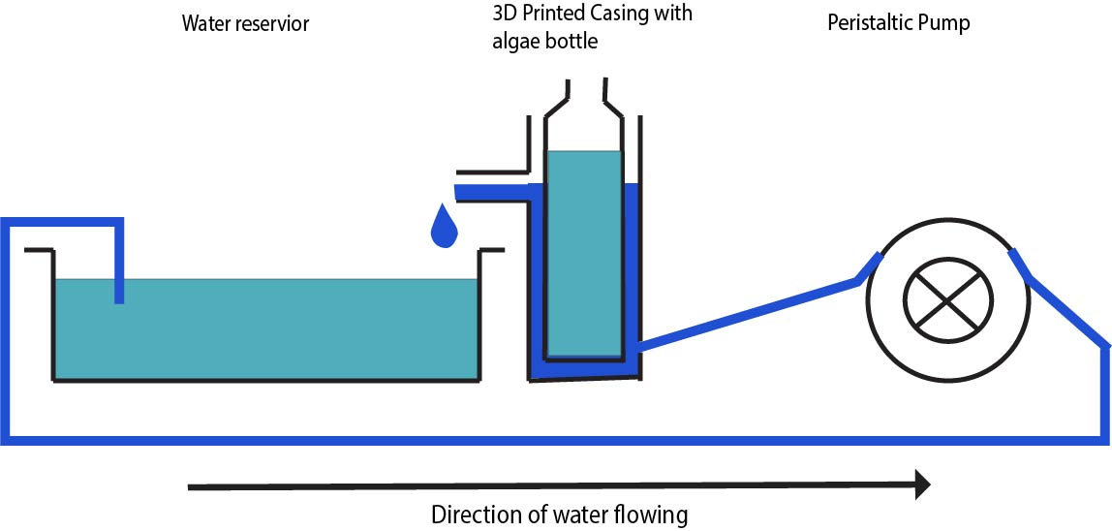

1. #how the experiment is conducted, to find

#how to find the theoretical value is a range

#experimental should be within theoretical

1. 1. The equation of control volume in the heat exchanger
   2. The rate of heat entering control volume
   3. The equation of control volume in the heat exchanger
   4. Express assuming is a constant
2. Plot

|  |  |  |  |
| --- | --- | --- | --- |
|  | 1.76 |  |  |
| ma (kg) |  | (Jg-1) | 4.18 |
| ca (Jg-1) |  | (K) | 308.65-302.65=6 |
| Tamb (K) | 298.15 |  |  |

1. Assumption of is valid, discuss